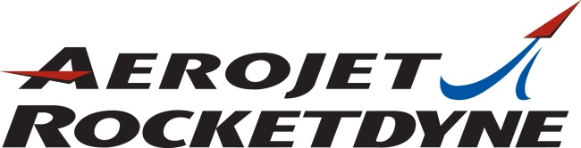

Senior EHS Engineer
Culpeper, Virginia

We are seeking a Senior Safety, Health & Environment Engineer (emphasis on safety!) to join our facility in Culpeper, Virginia. This is a great opportunity to support SH&E tasks as they relate to the manufacture, testing, and research & development (R&D) of solid rocket propellants, rocket motors, and related products. Typical duties:

- Reviews, analyzes, and evaluates facilities, operating equipment, methods, practices, and procedures for compliance with regulatory requirements, as well as company standards. Includes preparation of reports and applications for safety-related permits/licenses.
- Supports and/or leads safety compliance programs for PPE selection, hazard communication, ergonomics, indoor air quality/industrial hygiene and related monitoring, fire safety/loss prevention, and contractor safety.
- Participates in, supports and/or performs internal evaluations, inspections/audits, and surveys of processes, designs, procedures, operating equipment, and work sites to identify occupational hazards and recommend improvements/corrective actions to minimize/control the chemical, safety, and physical hazards and risk potential to employees and contractors.
- Participates in, supports and/or performs investigation of injuries and incidents/accidents, to determine their causes, and to recommend corrective/preventative actions to prevent their recurrence; discusses such problems and their solutions with supervisors and employees; and coordinates with responsible parties to track actions to closure.
- Functions as SH&E Training Coordinator; responsible for SH&E training plan and schedule; develops, updates, and conducts online and instructor-led SH&E training sessions for compliance with SH&E regulations and Company programs, initiatives, and standards; interacts with onsite Training Coordinator to ensure SH&E training courses and records are properly implemented/maintained in company-wide training system.

Requires a Bachelor's degree in Safety or a relevant science-based discipline with 5 years of directly related technical experience, or an equivalent combination of education and experience. Must be able to obtain and maintain a U.S. Security Clearance at the appropriate level (U.S. Citizenship required). Certified Industrial Hygienist or Certified Safety Professional preferred.

Visit our web site to apply online (look for job ID 14532):
www.rocket.com/careers

In addition to medical/dental/vision insurance, our benefits include a 401(k) with company match, tuition reimbursement, vacation, sick leave, year-end shut down and more.

