|  |  |  |  |  |
| --- | --- | --- | --- | --- |
|  |  | |  | | --- | | Colonial VA ASSE Chapter Update | | Spring 2018 | |
|  |  |  |
| Colonial VA Chapter Asse Newsletter – Late Spring 2018 |  | In This Issue |

Happy Spring everyone!

We have had a fantastic year of programming and have 2 more great events before the end of our Chapter’s 2017-2018 calendars. Your executive Committee has been very busy in 2018. Among the highlights was the Bi-Annual ROC meeting. The Regional Operating Committee (ROC) met here in Richmond, VA in March. This is a 2-day event where every Chapter in Region 6 sends a delegate and we decide on the direction of the Region as a whole. Our big focus was on networking, encouraging new volunteers, and our annual Professional Development Conference, which takes place every year in September in Myrtle Beach, SC.

Another big topic was our NEW NAME! Using your feedback, our society embarked on updating our brand identity by evolving our name—making it more inclusive, since only 3% of current members hold a Professional Engineer (P.E.) credential. We want to create one global brand to speak to *all* current members while encouraging new members to join.

We plan to implement use of the new organizational name and brand in alignment with SAFETY 2018, June 3-6, in San Antonio, TX, and the launch of our new website. You will then see it in email templates, presentations, our brochures and our journal, *Professional Safety*. Until June, the organization will conduct business as usual as the American Society of Safety Engineers (ASSE). Feel free to learn more at: <http://www.assp.org/our-story/>

At our May meeting, we will elect NEW OFFICERS for 2018-2019 as well! Please come and make your voice heard. Want to participate as an officer or a chairperson? Let us know!

It has been a true honor serving as your president this year. Best wishes and stay safe!

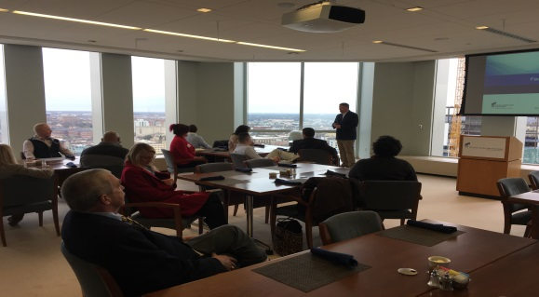

# Presidents Message:

by Amy Henderson CSP, CEAS

Chapter Updates & Events

Presidents Message Page 1

Upcoming Meetings/Event Page 2

Recent Event Updates Page 3

Legislative Update Page 4

General Announcements Page 5



Safety Spotlight: Contractor Safety

Top Ten safety issues publication Page 6

### Upcoming Meetings/Events:

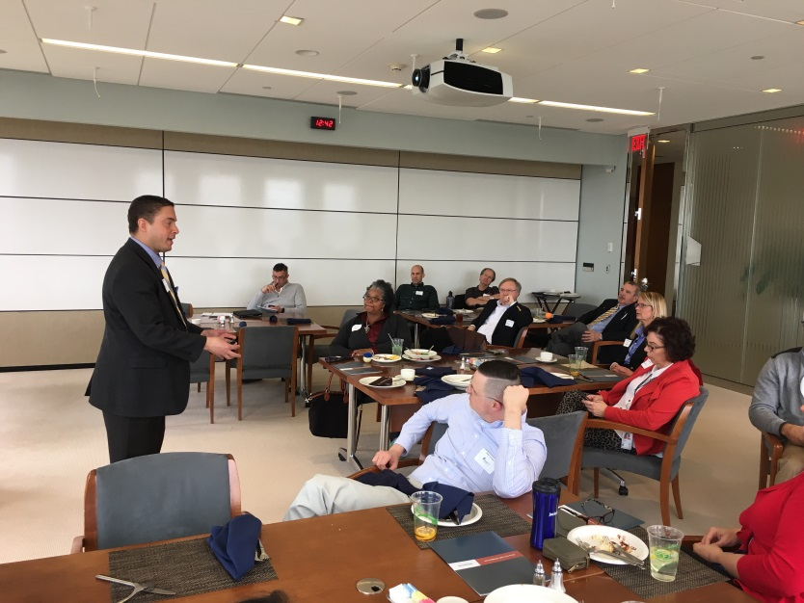Colonial VA ASSE Meeting Schedule (2018). Sign up here: <https://colonialva.asse.org>

* May Chapter Breakfast Meeting: May 21, 2018

8AM -10AM

Marty’s Grill 9357 Atlee Road, Mechanicsville VA, 23116

Chapter will elect officers and appoint committee chairs for 2018-2019!

Caption 1: Chapter members receiving a legislative update during a regular monthly meeting from Legislative Liaison Courtney Malveaux

* Richmond Flying Squirrels Baseball Game:

June 22, 2018

7:00 – 10:00PM

|  |
| --- |
| Safety Facts |
| Did you know that ​the period between Memorial Day and Labor Day is the deadliest time for teen crashes on our roadways? Get information on safe driving to share with your teen drivers at the links below:  <https://www.drivesmartva.org/> https://www.nsc.org/ |

### Recent Events:

By Jon Lehman, Chapter Secretary

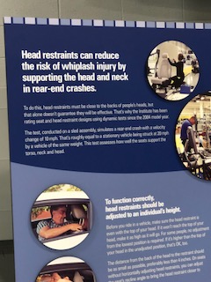

Fellow Colonial Chapter Members,

Colonial VA ASSE Chapter members had the opportunity to attend a chapter meeting at the IIHS testing facility in Ruckersville VA on May 15. It is believed this is the 6th year ASSE has been involved with this Drive Smart event with a focus on vehicle safety especially as it relates to distracted driving. All told, there were almost 100 people present including Safety Professionals, Law Enforcement, Academia, plus representatives from the Insurance and Private industry.

We got to see the crash testing of a Volkswagen Atlas and heard presentations accompanied by some highway statistics. It was a very nice overview of what the IIHS has done and where they have increased testing in other areas and also tested different vehicles.

Colonial ASSE will be a part of this event next year and I encourage those of you who have not been to be a part of the meeting in 2019. Likewise, I encourage you to consider the Drive Smart Summit coming up in September 2018 in Richmond.

As you are all aware, motor vehicle accidents is the number one cause of workplace injuries so let’s all encourage SMART and SAFE DRIVING!!!

Caption 2: Colonial VA ASSE members attend a regular monthly meeting with a site tour at PreCon in Chesterfield County!

|  |
| --- |
| Chapter Updates |

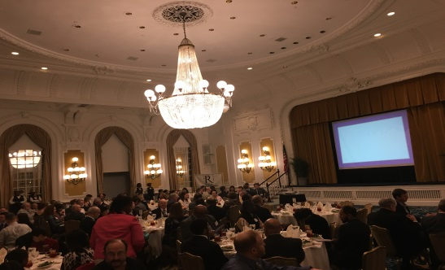

### Legislative Update

by Courtney Malveaux, Legislative Liaison

RJEC Banquet

The Richmond Joint Engineers Council held its annual awards banquet at the Jefferson on February 23,2018. Chapter VP, Matt Phillips, Chapter Secretary, Jon Lehman and Chapter Treasurer, John Meola were in attendance representing Colonial VA ASSE

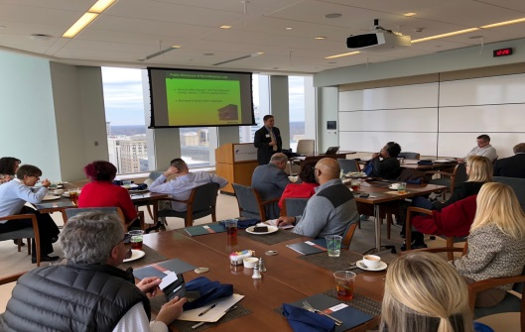

Federal Reserve Tour

Colonial VA members attending the April monthly meeting were treated to a review of safety, a legislative update and tour of the Federal Reserve!

|  |
| --- |
| Fast Facts |

|  |  |
| --- | --- |
|  |  |

658

People die every year due to heat illness

|  |  |
| --- | --- |
|  |  |

Did You Know?

Heat-related deaths are one of the deadliest weather-related health outcomes in the United States.

|  |
| --- |
| For More Information |
| For more information on heat related illness and it’s prevention in and out of the workplace, go to: US Center’s for Disease Control (CDC) https://www.cdc.gov/pictureofamerica/pdfs/picture_of_america_heat-related_illness.pdf |

The Trump Administration and the 115th Congress - - and many states - - have been smiling very favorably on Voluntary Protection Programs.

The Trump Administration introduced a budget that would fill most of the Compliance Assistance Specialist (VPP, SHARP and Consultation) positions lost in prior years. And it expressed a determination to provide new funding to clear backlogs of VPP applications and recertification. OSHA has held two open forums (including one at the last VPPPA Annual Conference) to ask for input on how to improve the program going forward. The agency appears inclined to utilize Special Government Employees more in order to boost the ranks of the 2,200-plus employers already in VPP, and it has encouraged regions to clear backlogs of VPP applicants awaiting certification.

Congress has also demonstrated more support than ever for VPP. In a recent hearing of the House Subcommittee on Workforce Protections, the Chairman opened the hearing with his compliments for a VPP worksite he visited recently. The VPP Act, a bill that would make VPP a permanent part of OSHA, has an impressively bipartisan show of support from 61 House Members and two Senators who signed on to the legislation (H.R. 1444 in the House of Representatives and S. 1878 in the Senate).

States have gotten in on the act as well. Indiana has long had a VPP Act on its books, and in recent years, Virginia, Arizona and Maryland have followed suit, with more states looking to follow. Just as important, many State Plan states are devoting more resources to increase VPP participation.

**How can you support VPP?**

You can support VPP today by “going viral” on social media or e-mail and share the following link with colleagues, friends and VPP supporters:

<http://www.bipac.net/issue_alert.asp?g=NuStar&issue=vpp&parent=NUSTAR>.

The link enables you to send a message supporting the VPP Act to your Congressional representatives. All you have to do is type in your name, address and e-mail, and then click on “Print/Send” on the following screen. Please share this information with others and show your support for VPP

Courtney Malveaux is a regulatory, government affairs and corporate attorney who defends companies cited by OSHA at Jackson Lewis, P.C. in Richmond, Virginia.  An experienced litigator, he served as Virginia’s Labor Commissioner through October 2013, and as President of the National Association of Government Labor Officials.  Malveaux represents industrial employers on the Virginia Safety and Health Codes Board, and serves as Government Affairs Counsel for the Voluntary Protection Programs Participants’ Association.  He can be reached at (804) 212-2862 or at Courtney.Malveaux@jacksonlewis.com.

**OSHA Issues Direct Final Rule Revising Beryllium Standard for General Industry**

**WASHINGTON, DC** – The Occupational Safety and Health Administration (OSHA) today issued a [direct final rule (DFR)](https://s3.amazonaws.com/public-inspection.federalregister.gov/2018-09306.pdf) clarifying aspects of the beryllium standard for general industry as it applies to processes, operations, or areas where workers may be exposed to materials containing less than 0.1% beryllium by weight.

The DFR clarifies the definitions of Beryllium Work Area, emergency, dermal contact, and beryllium contamination.  It also clarifies provisions for disposal and recycling, and provisions that the Agency intends to apply

only where skin can be exposed to materials containing at least 0.1% beryllium by weight.

The direct final rule will become effective on July 4, 2018, unless the Agency receives significant adverse comments by June 4, 2018.



**U.S. Department of Labor Fixes Error in the Improve Tracking of Workplace Injuries and Illnesses Regulation**

**WASHINGTON, DC –** Following a review of the requirements put in place in 2016 regarding the “Improve Tracking of Workplace Injuries and Illnesses” regulation, the U.S. Department of Labor’s Occupational Safety and Health Administration (OSHA) has taken action to correct and error that was made

implementing the final rule.

OSHA determined that Section 18(c)(7) of the Occupational Safety and Health Act, and relevant OSHA regulations pertaining to State Plans, require all affected employers to submit injury and illness data in the Injury Tracking Application (ITA) online portal, even if the employer is covered by a State Plan that has not completed adoption of their own state rule.

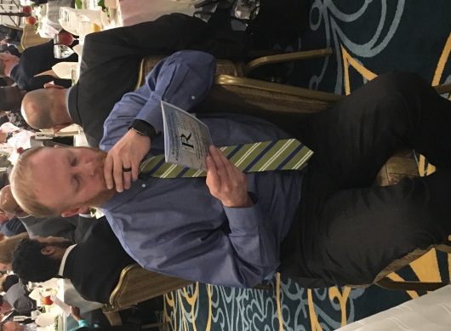OSHA immediately notified State Plans and informed them that for Calendar Year 2017 all employers covered by State Plans will be expected to comply. An employer covered by a State Plan that has not completed adoption of a state rule must provide Form 300A data for Calendar Year 2017.  Employers are required to submit their data by July 1, 2018. There will be no retroactive requirement for employers covered by State Plans that have not adopted a state rule to submit data for Calendar Year 2016.

|  |
| --- |
| For More Information |
| For more information on OSHA/VOSH and recent legislative updates or updates to existing OSHA standards, go to: OSHA & VOSH Website: <https://www.osha.gov>  <https://www.doli.virginia.gov/vosh> |

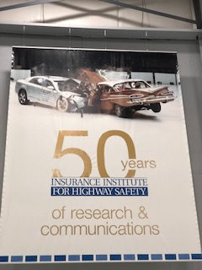

Join DRIVE SMART Virginia for the 6th Annual Distracted Driving Summit being held on September 19-20, 2018 at the Doubletree Richmond-Midlothian. **New for this year! ASSE members are being offered a special discounted registration rate of $165!** DRIVE SMART Virginia has indicated they have been lining up a strong list of corporate speakers for the event this year. Please use the code “ASSE18” in the discount code box on the payment page of your registration. For more information on the Summit and to register for the event, [use this link](http://www.cvent.com/events/6th-annual-distracted-driving-summit/event-summary-a47f91107641466694949206c784bcb6.aspx).

If you are a federal employee, postal worker or member of the U.S. military, please consider giving to DRIVE SMART Virginia through your Combined Federal Campaign.

**Our CFC Code is 81999**

**Virginia Employees: Our CVC Code is 050749**

|  |
| --- |
| Distracted Driving summit 2018 |

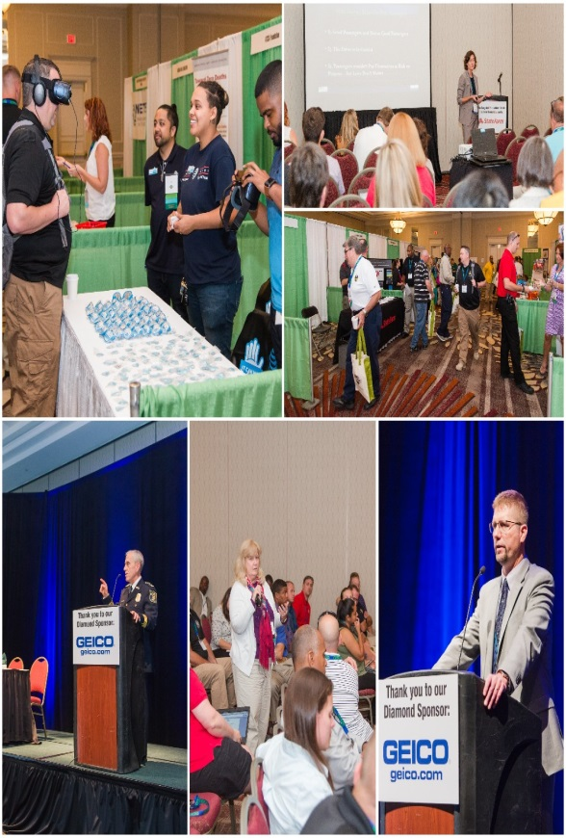

### VA DriveSmart Distracted Driving Summit 2018

After many years in the safety-consulting business, we have often heard the loud chorus of employer complaints aimed at “*Why do I need to do all this Safety Stuff?”*

Top Ten Safety Issues for Small to Mid-Size Contractors “Real or Imagined”

By John Meola, CSP, ARM, Safety Director (Pillar Inc) Chapter Treasurer

In the interests of educating the contracting community on the bare minimum obligations to protect their employees, here is a brief summary of the ***Top 10 Safety Issues for Contractors***.

# 10) “No one told me I had to train these guys.”

Correct. You will not receive an engraved invitation from anyone on this topic. However, if you decide to open a construction business, you should be perceptive enough to understand, “There are rules in this game….”

Employer responsibilities for worker safety are actually fairly straightforward and relatively simple to meet. Visit the OSHA.gov web page. There are simple tutorials available paid for by your tax dollars.

9) “We are the best at what we do.”

Along with trade proficiency, your employees should also have matching safety skills depending on your line of work. Most large general contractors are increasing the contractor safety program admission criteria to bid their jobs. Just doing the job on time, on spec. and under budget is no longer enough. Proof of safety performance is necessary.

8) “Don’t blame us! We didn’t create that hazard!”

OSHA and VOSH (Virginia’s safety police department) have heard this excuse a lot. They actually have an answer for it called the Multi-Employer Worksite Policy. This doctrine basically holds all contractors on a site accountable if their employees were “exposed” to a hazard. You can be found at fault if you were just near the hazard. Your defense for this allegation is called due diligence and documented communication to the responsible parties about the hazard. In the meantime, if necessary, move your people well out of harm’s way.

7) “He’s my best guy, but he just won’t follow the safety rules.”

This statement is self-contradictory. For a tradesperson to be truly proficient, he or she will understand and adhere to applicable safety practices. You should be highly supportive of that. Your “best person” may need re-education or the exit door. Whether you realize it or not, you have a lot at risk from a rogue actor.

6 “Now my insurance company is pestering me about safety.”

Welcome to the new reality. The insurance company wrote coverage for your operation, therefore it expects you to play by the rules. Even the simplest of claims can turn ugly, so prevention is the preferred avenue of relief. Blatant non-compliance could result in revocation of coverage or big premium increases at renewal. Or you may end up in the assigned risk pool; in which case, you will regret not having done more of this safety stuff.

5) “There was nothing we could have done to prevent the accident.”

Au contraire. Even the most conservative appraisals classify preventable incidents in the high 90th percentile range. Most, if not all, incidents are preventable. Incident prevention is a matter of degree and commitment, but, at the end of the day, there is a simple list of must haves to gain admission. Trust me: With a little effort, you can avoid this stuff. Acts of God notwithstanding.

4) “The cost of doing all this safety stuff will put me out of business.”

When properly understood and applied, safety compliance is actually a small component of doing business. You are either in denial or hysterically misreading the safety rules. Yes, the rules can seem voluminous. Once understood, they’re actually not all that onerous. Try to get out of the office more often.

3)“We have a good track record; we don’t need all this safety stuff.”

This is a commonly heard refrain in the safety business. The translation of this remark is, “We’ve just been lucky, that’s all.” Reliance on your luck as a substitute for a safety program is ill-advised. Yes, most tradespersons will exercise a healthy degree of caution on the job without you lifting a management finger. But more complex work or even just driving around in the company truck deserves reciprocal attention for the risks involved. For example, If you have employee driver fleet units, you should regularly be preaching defensive-driving practices.

2) “We are not worried about workplace violence; we got that covered.”

Not so fast. There is a lot of liability attached to the issue of workplace violence. A couple of simple maneuvers can help protect your organization and also help educate employees for prevention. We will most assuredly see a lot more emphasis on this issue in the near future from the authorities. Interestingly, there is currently no direct OSHA requirement to do anything for violence prevention. However, prudent management should step forward and define the policy and procedure.

10) “I thought all this red tape was going to be reduced.”

Don’t hold your breath. OSHA and the DOL may be temporarily underfunded, but the ABA and trial lawyers have the best lobbyists and wealthiest power grid on the planet. You might skate on compliance if your GC and client are sound asleep, but the legal community never rests. At least the safety police will treat you fairly depending on your transgression. Tort law and claim adjusters will be less kind.

Summary: Statistically, our population is most at risk from driving to and from work every day compared to on the job. Workplace safety is ingrained into our societal DNA at this point, and regulatory compliance is largely taken for granted.

Business risk management, which includes occupational safety, has long been a monolithic field that rivals Stonehenge. That state of slumber is undergoing an awakening, and it is happening very quickly.

For additional reading, check out: www.doli.virginia.gov/ vosh_enforcement/vosh_standards.html



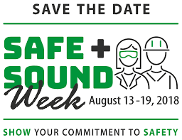

|  |  |  |
| --- | --- | --- |
| For more information on the Colonial VA ASSE Chapter and its membership, please visit us at |  |  |
|  |  |  |